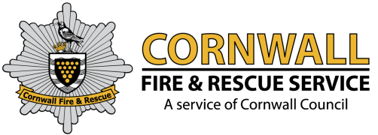

Cornwall Fire, Rescue and Community Safety Service

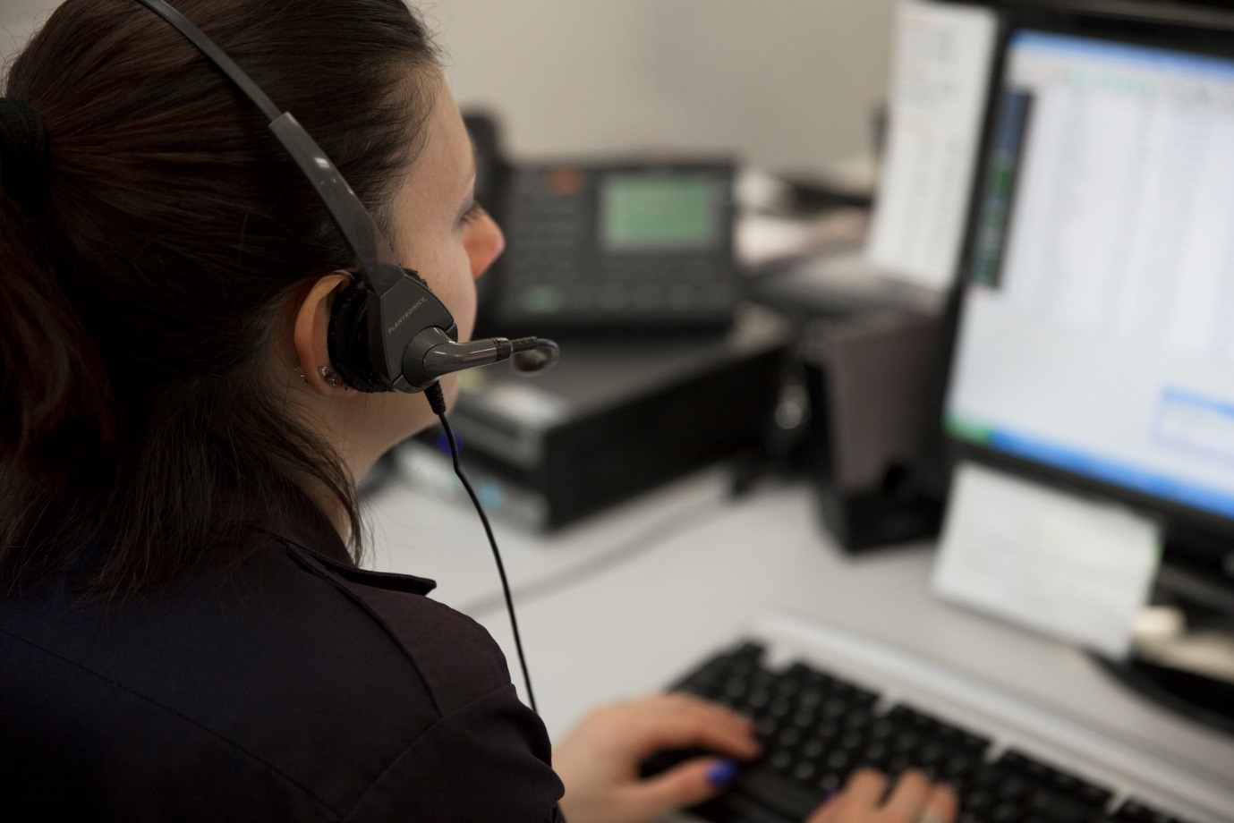

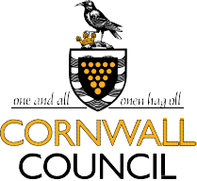

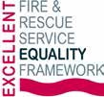
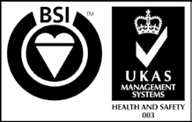
Updating the Incident News desk
About this document
This document has been produced to assist Critical Control Operators to provide additional supporting information on preventative measures that can be learnt by the media and members of the public after an incident has taken place.

How to use this document
Use the bookmarks located on the main page and select the title that is relevant to support the incident you are updating. The link will take you directly to the preventative information.
Copy and paste text from the subject that you need and add it as additional advice and guidance under your content about the incident.

Web links to further information
Copy the link provided from the subject that you need and paste it into the “Link to related item” field of the news desk.
The links found within this document assist us in seeing how many people visit the page from the news desk and social media.

Provide a suitable image
Add an image when appropriate to your log. Images found within this document are all available to use and can be uploaded from the ‘Reference’ drive located at:
R:\TEMPLATE\Critical Control - News Desk\Images
To assist you, there is a reminder on how to browse to this folder from each page.

Service social media accounts
Check the live social media feeds of our Service accounts for use within your update. If you spot anything of concern, contact the Info Hub team immediately or take action yourself by contacting the relevant account holder.
Account holders are listed from the Service social media accounts web page:
http://bit.ly/2jqWuhk
Quick links to information held within this document:

Logging onto the News Desk to add an incident

Subjects:
Animal rescue
Arson
Barbecues
Boat fires
Bonfires
Candles
Caravans
Carbon monoxide
Chimney fires
Chip pan fires
Cigarettes / smoking
Co-responders and First Responders
Community Fire Stations
Controlled burning
Countryside
Driving in heavy rain and floods
Driving in snow and ice
Electrical fires
False alarms
Farms
Fire investigation dog
Fire safety in the home
Firework safety
Flooding
Frying
Gas leak
Hoarding
Home fire safety check
Hoax calls
Kitchen fires
Outdoor fire safety
Oxygen users
Paraffin based creams
Red Cross Emergency Response vehicle
Reducing the risks in winter
Road traffic collisions
Severe cold weather
Smoke alarms
Smoking / cigarettes
Snow and ice in Cornwall
Thatch cottages
Tumble dryers
Washing machines
Wild fires

Monthly Fire Kills safety campaigns:
January
February
March
April
May
June
July
August
September
October
November
December

Logging on to the News Desk to add an incident
Step 1 - Log on to add an incident making sure you only use Internet Explorer as Google Chrome is not currently compatible.
Save this link as a bookmark to your bar:
https://db.cornwall.gov.uk/fbnews/admin/login.asp
(If you have forgotten your log in details, email the infohub@fire.cornwall.gov.uk and your password will be reset)
Step 2 - Fill out the details of the incident – Title of news item, location of incident, date & time of incident.
Step 3 - Using this template, we advise you to fill out the details of the news item in the space provided below to automatically check your spelling.
Type your draft incident update here
Step 4 – Highlight your text above and copy (ctrl c) and paste (ctrl v) it into the large section – “Details of the news item”.
Step 5 – If beneficial, link to a related item and add the supporting text (found in the table below) and add it with your information to direct people to more information on the Cornwall Fire, Rescue and Community Safety Service website.
Things to note:
The Business Support team will proof read all incident updates and amend any logs as necessary. They are there to support the communications of the Service so keep them updated as much as possible during the weekday 8am – 5pm.
- Remember to only abbreviate a term when it has been written in full first. Those viewing our updates do not understand the terminology so we must use plain English at all times.
- Never refer to a road traffic accident (RTA) – it must be written as a road traffic collision (RTC).
- Add an update if further information about an incident is obtained that may be of use to the public / press. This avoids the media contacting us directly asking for more information.

Return to top
Animal rescues
For further details on how we respond to animal rescues, visit the link below where more information and advice can be found.
Link- http://bit.ly/2rg7MsS
Image - This can sometimes be images taken from the incident; pictures taken must have the permission of an Incident Commander and the individual/s involved. If there are no images just stick to using the above text and link.

Return to top
Arson – also within ‘Fire Investigation dog’
General text to use:
Anyone with information on fires being deliberately started in the countryside are advised to anonymously call Crimestoppers free on 0800 555 111 or contact Devon and Cornwall Police on 101 with information.
Arson puts both the public and firefighters at unnecessary risk. It ties up resources that could be in demand for other more serious incidents.
A lot of Cornwall is covered by on-call firefighters, so there's also a significant cost to each incident.
Text for when incident where the fire dog is used:
Cornwall Fire and Rescue Service are one of a handful of services within the UK to employ the services of their own fire investigation dog team.
The dogs are used as a tool to search cold, post-fire scenes for the presence of flammable and ignitable liquids that could have been used to start or promote fires deliberately.
Arson does not only threaten lives and damage property it has a detrimental effect on communities and the lives of people within them.
Anyone with information on fires being deliberately started are advised to anonymously call Crimestoppers free on 0800 555 111 or contact Devon and Cornwall Police on 101 with information.
Help protect yourself, friends, family and others from the threat of arson by viewing our information on our website which is available from the link below:
Copy this link into the link bar - http://bit.ly/2iAfKfa
Image – \\cc\root\fire\ref\TEMPLATE\CriticalControl_NewsDesk\Images\Logos


Return to top
Barbecues
Although most barbecues present no problems, there have been examples of fires, serious injuries and deaths caused by the use of flammable liquids or sitting barbecues too close to fences, garden sheds, buildings or trees. Select the related link below to view guidelines that will help ensure that everyone has a happy and safe barbecue season:
Link - http://bit.ly/MEcmZq
Image - R:\TEMPLATE\Critical Control - News Desk\Images\Campaigns
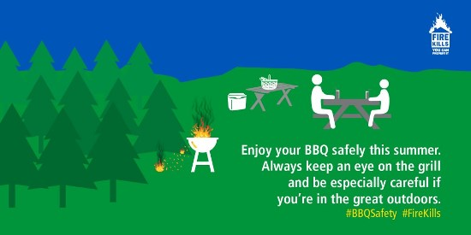

Return to top
Boat fires
Did you know that in the past 20 years, 30 boaters were killed in boat fires and another 30 lost their lives to the highly toxic carbon monoxide (CO) gas? Most fires are preventable and the following link provides tips and advice on how to protect your boat and crew from fire and what to do should a fire break out.
Link - http://bit.ly/27TG9FI
Image - R:\TEMPLATE\Critical Control - News Desk\Images\Campaigns
Image - R:\TEMPLATE\Critical Control - News Desk\Images\LeafletCovers
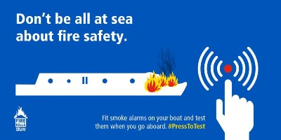
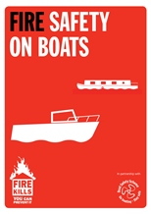

Return to top
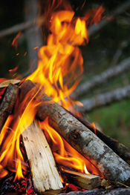
Bonfires – also within ‘Controlled burning’
If you are planning a large bonfire in Cornwall, inform Cornwall Fire, Rescue and Community Safety Service before you start by dialing 0203 162 2240 and tell the Critical Control Operator:
- Your location.
- Time you intend to start burning.
- Confirm when you have finished burning.
This helps us avoid sending fire engines to false alarms when they could be responding to a real emergency.
With controlled burns, it is illegal to leave a fire unattended or to have too few people to control it. Always ensure a fire is completely out before you leave it and check next day to ensure it has not reignited.
Link - http://bit.ly/2iVrl74
Image - R:\TEMPLATE\Critical Control - News Desk\Images\Incidents

Return to top
Candles
Candles are actually a rising cause of fire. Every year, a growing number of people are killed or injured because they are careless with them. By following these guidelines, you can reduce the risks that come with using candles.
For some safety tips when using candles, visit our website:
Link - http://bit.ly/WxrXeg

Return to top
Caravan fires
It’s important to remember that fire safety doesn’t stop when you leave the house. To find out more information on the potential hazards whilst camping outdoors and how to prevent a fire, select the related link below:
Link - http://bit.ly/2hWjswl
Image - This could be provided from the incident depending on the appropriateness and picture quality. Images will need agreed permission from an incident commander and person/s involved. Alternatively images that could be used are available from the R:Drive – One example can be found below:
Image - R:\TEMPLATE\Critical Control - News Desk\Images\Campaigns
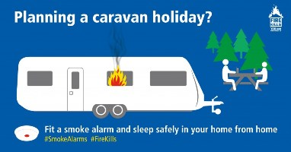

Return to top

Carbon monoxide
Carbon monoxide is potentially fatal and even low-levels of the poison can cause lasting damage to your health. You can't smell it, see it or taste it, but it could be there now.
Further information and guidance regarding carbon monoxide can be found on the following link.
Link- http://bit.ly/2cXqh1M
Image - R:\TEMPLATE\Critical Control - News Desk\Images\Campaigns
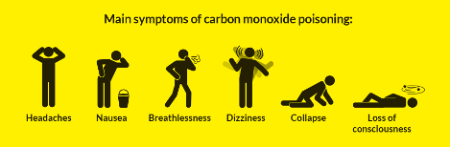

Return to top
Chimney fires
During 2016/17 Cornwall firefighters tackled 155 chimney fires. Most chimney fires are preventable by having them swept regularly.
For further information and advice, visit our chimney fire webpage through the link below.
Link- http://bit.ly/2bYexuJ
Image - This could be provided from the incident depending on the appropriateness and picture quality. Images will need agreed permission from an incident commander and person/s involved. Alternatively images that could be used are provided below as they are generic chimney fire safety images, which can be located at:
Image - R:\TEMPLATE\Critical Control - News Desk\Images\Campaigns
Image - R:\TEMPLATE\Critical Control - News Desk\Images\LeafletCovers
Image - R:\TEMPLATE\Critical Control - News Desk\Images\Incidents

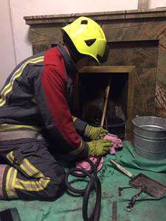
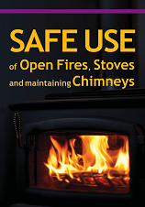
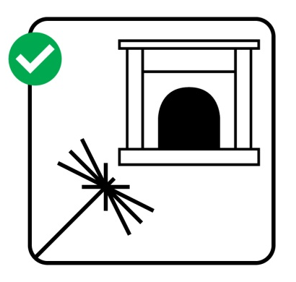

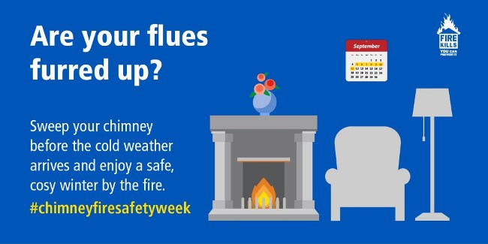
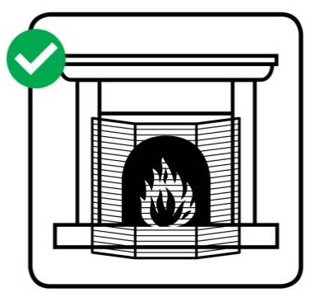

Return to top
Chip pans – also within Deep-Fat Frying
Deep-fat frying presents more dangers in your kitchen. Chip pans are safe as long as you follow some simple guidelines.
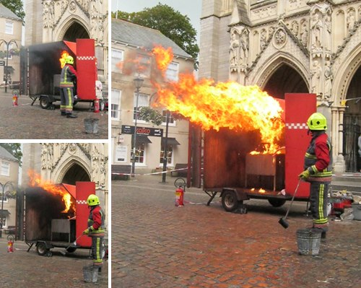
Before putting food in the pan dry the food, and test the temperature of the oil by putting in a small piece of bread. If the bread crisps quickly the oil is ready.
Remember:
- Never fill a chip pan (or other deep-fat fryer) more than one-third full of oil
- Never leave the pan unattended when the heat is switched on
- Never put the food in the pan if the oil begins to give off smoke. Turn off the heat and leave the oil to cool, otherwise it could catch fire
- Consider using a thermostatically controlled deep-fat fryer - this will ensure that the fat does not get too hot
- If your pan does catch fire: Don't take any risks.
- Turn off the heat if it's safe to do so.
- Never throw water over it.
- Don't tackle the fire yourself.
- Get out, stay out and call 999!
Whatever you do, don't throw water over the fire and don't move the pan; the effects can be devastating.
If you are in any doubt about whether to try and put out a chip pan fire yourself, then don't - leave the room, close the door and call the Fire and Rescue Service.
For more information on preventing a kitchen fire, select the link below:
Link - http://bit.ly/2cECKX0
Image - R:\TEMPLATE\Critical Control - News Desk\Images\Incidents
Cigarettes
To prevent a cigarette fire in your home, view our help page found from the link below:
Link - http://bit.ly/154MpHv
Image - This could be provided from the incident depending on the appropriateness and picture quality. Images will need agreed permission from an incident commander and person/s involved. Alternatively images that could be used are available from the R:Drive – One example can be found below:
Image - R:\TEMPLATE\Critical Control - News Desk\Images\Campaigns

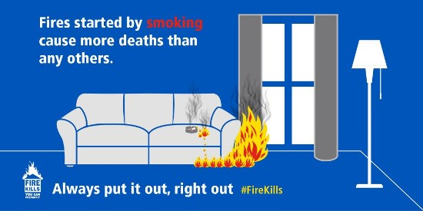

Return to top
Co-responders and first responders
Last year (2016/17), we attended 819 co-responder calls.
Firefighters from six Community Fire Stations in Cornwall help the community by not only providing fire cover but also act as a co-response resource in medical care, through partnership with South Western Ambulance Service NHS Foundation Trust (SWASFT). The scheme has been running since 1999, serving the communities of St. Keverne, St. Ives, Mullion, St. Mawes, Helston and Polruan.
To find out more about co-responders, visit the link below:
Link - http://bit.ly/N0Puya
Image - R:\TEMPLATE\Critical Control - News Desk\Images\Incidents
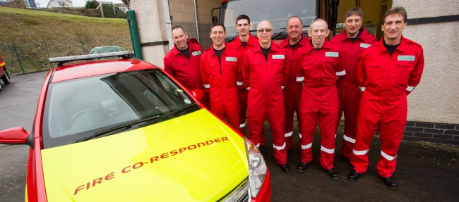

Return to top
Community Fire Stations
Community fire stations are at the heart of our communities. See more about your nearest station and where your nearest station is.
Link - http://bit.ly/2f90JMM
Image - R:\TEMPLATE\Critical Control - News Desk\Images
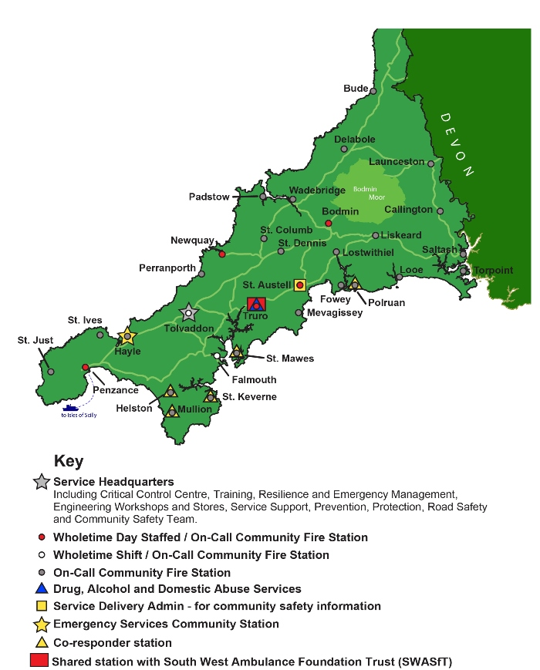

Return to top
Controlled burning – also within ‘bonfires’
If you are planning a large bonfire in Cornwall, inform the Fire and Rescue Service before you start by calling our Critical Control Centre on 0203 162 2240.
Tell the Critical Control Operator:
- Your location.
- Time you intend to start burning.
- Confirm when you have finished burning.
This helps us avoid sending fire engines to false alarms when they could be responding to a real emergency.
For more information regarding controlled burns and bonfires visit the link below.
Link - http://bit.ly/2iVrl74
Image - R:\TEMPLATE\Critical Control - News Desk\Images\Incidents

Return to top
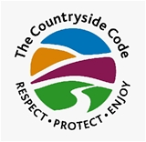
Countryside
If arson – see section titled ‘Arson’ for supporting text.
If not use:
For more information on how to prevent a fire in the countryside, select the related link below:
Link - http://bit.ly/2jSErDm
Image - This could be provided from the incident depending on the appropriateness and picture quality. Images will need agreed permission from an incident commander and person/s involved.
Image – \\cc\root\fire\ref\TEMPLATE\CriticalControl_NewsDesk\Images\Logos

Return to top

Driving in heavy rain and floods
Driving in heavy rain and flooding can be very dangerous, stopping distances increase dramatically, visibility is severely impaired and standing water increases the chance of your vehicle aquaplaning.
Find out more on what to be aware of when driving in heavy rain and floods:
Link - http://bit.ly/1Pem997
Image – R:\TEMPLATE\CriticalControl_NewsDesk\Images\Logos
Image – R:\TEMPLATE\CriticalControl_NewsDesk\Images\Weather
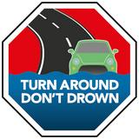
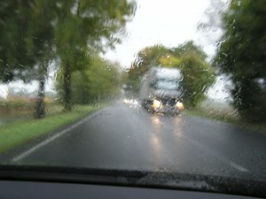

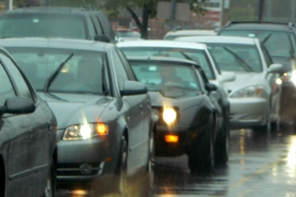

Return to top
Driving in snow and ice
Driving in snow, ice and wintry conditions requires extra care and preparation, and you should only drive when absolutely necessary. Please read our guidelines on safe winter driving.
Link - http://bit.ly/2h558Rz
Image – R:\TEMPLATE\CriticalControl_NewsDesk\Images\Weather

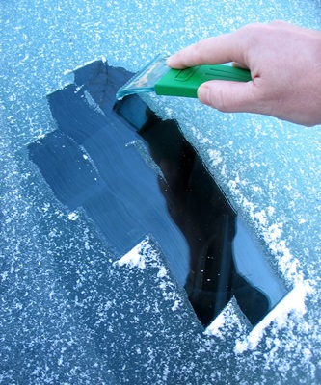

Return to top
Electrical fires
Electricity is often overlooked as a possible fire hazard. This may be because there is no flame. However, some 28,000 fires in the home are reported each year as being caused by electrical faults, accidents or misuse of electrical equipment.
Did you know the average success rate of an electrical product recall in the UK is just 10-20%. This means that there are potentially millions of recalled electrical items still in UK homes. As most of these products have been recalled because they offer a risk of electric shock or electrical fire, they present a serious risk.
If you have recently brought an electrical appliance make sure you register them at www.registermyappliance.org.uk so you know about any repairs or recalls.
Visit the link below for more information and guidance around electrical fire safety.
Link - http://bit.ly/1UzNapq
Image - R:\TEMPLATE\Critical Control - News Desk\Images\Campaigns
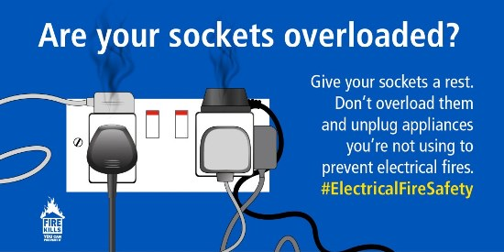

Return to top
False alarms
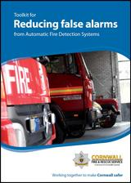
Cornwall Fire, Rescue and Community Safety Service have developed a toolkit to help businesses reduce the number of false alarms from automatic fire alarm systems, limit business disruption and free up our resources for other essential activities. By following our guidance in our toolkit you could reduce/eliminate the disruptive impact of false alarms, improve productivity and save money.
The guidance covers the following:
- Your responsibilities
- What is a false alarm?
- How many false alarms are too many?
- Fire alarm management
- Emergency plan
- Action we take help reduce false alarms
- How we respond to reported automatic fire alarms

View the booklet from the link below:
Link - http://bit.ly/2ko01Ny
Image - R:\TEMPLATE\Critical Control - News Desk\Images\LeafletCovers

Return to top
Farms
If arson – see section titled ‘Arson’ for supporting text to include.
Don’t Become a Statistic!
Every year we attend numerous fires on farms, where buildings are completely destroyed by fire, often with the loss of large amounts of stock, straw, hay, farm machinery, chemicals and even livestock.
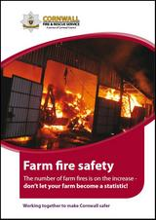
We have produced a booklet in partnership with Cornish Mutual and NFU Mutual to help farms comply with the new fire laws.
The booklet contains the information on the following:
- What you’re required to do by law
- Fire safety risk assessments
- If a fire breaks out
- Controlled burning
- Dangerous substances
- Arson
View the booklet from the link below:
Link - http://bit.ly/2knTvXm
Image - R:\TEMPLATE\Critical Control - News Desk\Images\LeafletCovers
Image - This could also be provided from the incident depending on the appropriateness and picture quality. Images will need agreed permission from an incident commander and person/s involved.

Return to top
Fire Investigation Dog – also within ‘Arson’
Cornwall Fire, Rescue and Community Safety Service are one of a handful of services within the UK to employ the services of their own fire investigation dog team.
The dogs are used as a tool to search cold, post-fire scenes for the presence of flammable and ignitable liquids that could have been used to start or promote fires deliberately.
Arson does not only threaten lives and damage property it has a detrimental effect on communities and the lives of people within them.
Anyone with information on fires being deliberately started are advised to anonymously call Crimestoppers free on 0800 555 111 or contact Devon and Cornwall Police on 101 with information.
Help protect yourself, friends, family and others from the threat of arson by viewing our information on our website which is available from the link below:
Copy this link into the link bar - http://bit.ly/2iAfKfa
Image - This could be provided from the incident depending on the appropriateness and picture quality. Images will need agreed permission from an incident commander and person/s involved.
Contact Mark Smith to request an image or select one from the image folder.
Image – \\cc\root\fire\ref\TEMPLATE\CriticalControl_NewsDesk\Images\Logos

Return to top
Red Cross Emergency Response vehicle
Further information about the Red Cross Emergency Support vehicle can be found from our website:
Link: http://bit.ly/2qVVVyM
Images - Image - R:\TEMPLATE\Critical Control - News Desk\Images\Incidents
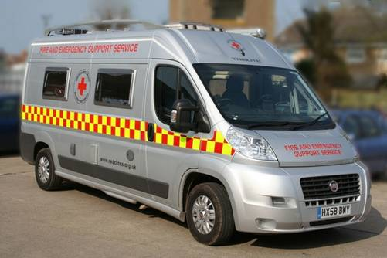

Return to top
Fire safety in the home
Over 80% of all casualties occur as a result of fires in the home. The majority of these fires are accidental and could have been prevented by following a few simple measures which help to reduce the risks. Take a look at our information to prevent a fire in your home.
Link - http://bit.ly/29hew3W

Return to top

Firework safety
To report misuse of fireworks, call your local police (Devon and Cornwall) by dialling 101 or call Crimestoppers anonymously, on 0800 555 111.
For further information on firework safety, visit our web page:
Link - http://bit.ly/2f8xDgA
Images – R:\TEMPLATE\Critical Control - News Desk\Images
Image - R:\TEMPLATE\Critical Control - News Desk\Images\LeafletCovers
Image - R:\TEMPLATE\Critical Control - News Desk\Images\Seasonal
Image – \\cc\root\fire\ref\TEMPLATE\CriticalControl_NewsDesk\Images\Logos
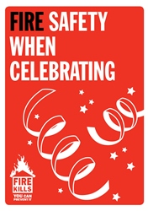
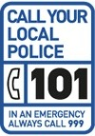



Return to top

Flooding
In the event of major flooding in the county, Cornwall Fire, Rescue and Community Safety Service work closely with other agencies to deliver a coordinated approach to the operation.
For advice on how you can prepare and try to minimise damage and the risk of flooding please see the link below. Alternatively you can call Floodline on 0345 988 1188 any time night or day for real-time flood warnings and advice, including registration to the Flood Warning Services.
Link - http://bit.ly/1kOgBzh

Return to top
Frying – also within in ‘Chip pans’
Deep-fat frying presents more dangers in your kitchen. Chip pans are safe as long as you follow some simple guidelines.
Before putting food in the pan dry the food, and test the temperature of the oil by putting in a small piece of bread. If the bread crisps quickly the oil is ready.
Remember:
- Never fill a chip pan (or other deep-fat fryer) more than one-third full of oil
- Never leave the pan unattended when the heat is switched on
- Never put the food in the pan if the oil begins to give off smoke. Turn off the heat and leave the oil to cool, otherwise it could catch fire
- Consider using a thermostatically controlled deep-fat fryer - this will ensure that the fat does not get too hot
- If your pan does catch fire: Don't take any risks.
- Turn off the heat if it's safe to do so.
- Never throw water over it.
- Don't tackle the fire yourself.
- Get out, stay out and call 999!
Whatever you do, don't throw water over the fire and don't move the pan; the effects can be devastating.
If you are in any doubt about whether to try and put out a chip pan fire yourself, then don't - leave the room, close the door and call the Fire & Rescue Service.
For more information on preventing a kitchen fire, select the link below:
Link - http://bit.ly/2cECKX0
Image - R:\TEMPLATE\Critical Control - News Desk\Images\Incidents
Gas leak
What to do if you smell gas
If you smell gas in your home follow this important information:
- If you smell gas or think that you may have a gas leak somewhere, then you should call the national gas emergency service straightaway on 0800 111 999 or the fire and rescue service, dialling 999 in an emergency situation.
- Do not turn lights on or off and avoid using other electrical switches and appliances.
- Turn off the gas at the meter, unless the meter is located in a cellar or basement - in which case, do not enter.
- If there is a smell of gas in the cellar or basement, you should evacuate the building.
- Extinguish all naked flames - do not smoke or strike matches.
- Open windows and doors to let air in, make sure all gas appliances are turned off and turn off the gas at the mains if possible - do not use until they are checked by the engineer.
- Keep people away should the area be evacuated.
- Immediate access will be required.
If you smell gas or are worried about gas safety, call the national gas emergency service free on 0800 111 999 at any time, day or night every day of the year. Just pick up the phone, dial the number and you will be put through to a trained operator who will take all the details.
All calls to the National Gas Emergency Service are recorded, and may be monitored.
Link - http://bit.ly/2k4uhzk
Image – \\cc\root\fire\ref\TEMPLATE\CriticalControl_NewsDesk\Images\Logos

Return to top
Hoarding
A hoarding disorder is where someone acquires an excessive number of items and stores them in a chaotic manner. The items can be of little or no monetary value and usually result in unmanageable amounts of clutter. It's considered to be a significant problem if:
- The amount of clutter interferes with everyday living – for example, the person is unable to use their kitchen or bathroom and cannot access rooms
- The clutter is causing significant distress or negatively affecting the person's quality of life or their family's – for example, they become upset if someone tries to clear the clutter and their relationships with others suffer.
If you have any queries regarding hoarding or you have concerns for a family member or neighbour, please contact the Access Team: 0300 1234 131 or email accessteam.referral@cornwall.gov.uk
You can also complete the online free home fire safety check form, call the free 24hr fire safety helpline on: 0800 3581 999 or contact us at St. Austell Community Fire station on 01726 72582. Further information can be found on our website:
Link - http://bit.ly/2uUIKkB
Image - R:\TEMPLATE\Critical Control - News Desk\Images\Incidents
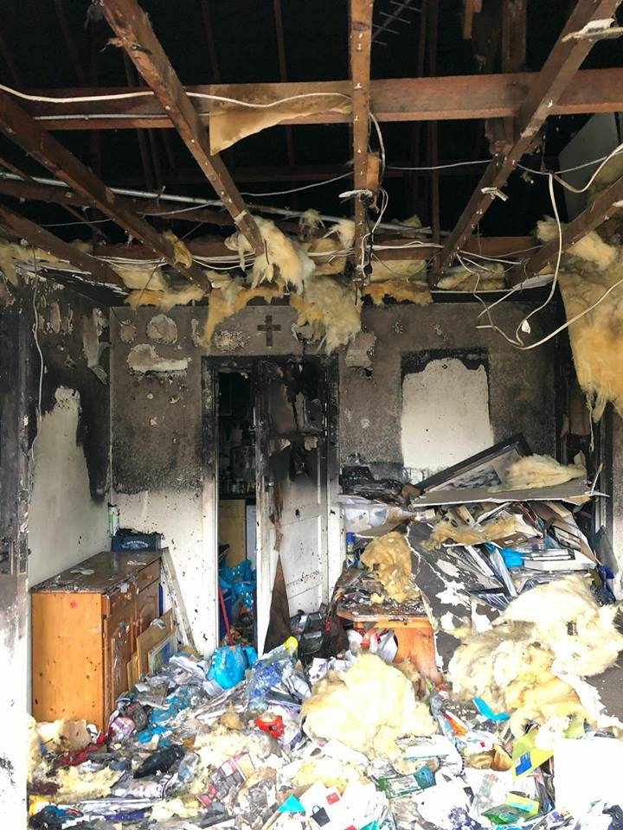
Return to top
Home fire safety check – *Note - soon to be ‘Living safe and well visit’
Over the past five years, 11 people have died and 13 people have been seriously injured in accidental dwelling fires in Cornwall.
In Cornwall, we are committed to reducing fire deaths by ensuring that every home in the county has a working smoke alarm. To make sure this happens, firefighters carry out free home safety checks and fit free smoke alarms.
To register for a free home fire safety check, select the related link below:
Link - http://bit.ly/29JEgFU
Image - R:\TEMPLATE\Critical Control - News Desk\Images

Return to top
Hoax calls
A hoax call to any Emergency Service could cost lives; tying up valuable emergency resources and preventing them from attending a real incident. If there had been a genuine emergency, resources would have to be called in from another station further away. Putting lives at risk.
Making hoax calls is illegal. People can, and have been, heavily prosecuted for making hoax calls with a fine of up to £5,000 or six months in prison.
Find out more about hoax calls on the link below.
Link - http://bit.ly/2h50pxS

Return to top
Kitchen fires
Cooking related fires can be very dangerous and over the past three years there have been two deaths and six serious injuries due to this type of incident. Nearly all of these fires occurred in the kitchen and the majority are related to the oven (60%) and then the grill/ toaster (15%).
Follow these simple tips found from the link below to help keep your kitchen safe.
Link - http://bit.ly/2cECKX0
Image - R:\TEMPLATE\Critical Control - News Desk\Images\Campaigns
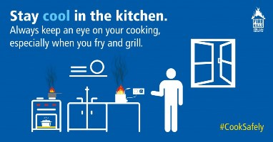

Return to top
Outdoor fire safety
Leisure activities such as barbecues, camping, caravanning and boating, should be relaxing and enjoyable experiences but it is important you're aware of the potential fire hazards that they pose. For more information on outdoor fire safety, select the related link below:
Link - http://bit.ly/2aZ7eyN
Image - R:\TEMPLATE\Critical Control - News Desk\Images\Campaigns

Return to top
Oxygen users
People who use oxygen in their homes for medical reasons are encouraged to arrange a free home fire safety checks.
If you use oxygen at home, call us on 0800 3581 999 to inform us.
By informing us about the oxygen products used and stored in your home, you will be providing vital help to firefighters in the event of a fire.
For safety measures to keep you and your family/ carers safe and limit the risk of fire if you smoke, visit our web page for further information:
Link: http://bit.ly/2n5upwV
Paraffin based creams
Did you know? If you use paraffin-based emollient products that are covered by a dressing or clothing, there is a danger that smoking - especially in bed or using a naked flame, could cause dressings or clothing to catch fire.
Examples of paraffin-based emollients include:
- white soft paraffin
- white soft paraffin plus 50% liquid paraffin
- emulsifying ointment
For example E45, petroleum jelly, aqueous.
Smoking or a naked flame could cause your dressings or clothing to catch fire when being treated with paraffin-based emollient that is in contact with the dressing or clothing.
For further help and advice about this danger, visit our web page:
Link - http://bit.ly/2me9r1a

Return to top
Reducing the risk of fire in winter
Cold weather can increase the dangers in your home through additional measures taken to keep warm. In the UK on average, 12,000 chimney fires occur every year.
Visit our website for some simple tips to consider during cold weather to prevent a fire from happening in your home:
Link - http://bit.ly/SvhKif

Return to top
Road traffic collisions
Find out more about Cornwall Fire and Rescue Service’s role when attending road traffic collisions by selecting the related link below:
Link - http://bit.ly/2rgmJuX
Image - R:\TEMPLATE\Critical Control - News Desk\Images\Incidents

Return to top
Severe cold weather
Snow and severe cold weather can cause disruption and can also affect more vulnerable people.
Practical steps
- To prevent freezing of internal pipes it is recommended that you turn off your water supply to prevent pipes from bursting. Locate the stop-cock inside your home; this is usually under the kitchen sink. Also, know the location of the stop-cock outside of your home, if you cannot find it, contact South West Water.
- Keep torches (and any batteries) to hand in case lighting fails or you need to switch off power.
- Keep important emergency numbers near your home - a 24-hour plumber, an emergency salvage and clean-up company, usually listed under 'Carpet and Upholstery Cleaners' in directories.
- Check your buildings and contents insurance details. Most will be pleased for you to arrange damage limitation with plumbers and cleaners yourself. Note any emergency contact telephone numbers.
- If your house has any exposed pipes, lag them with thick material, old blankets etc. If lofts are very cold, leave trap doors open.
- If you are away from your house overnight or for any long period, leave the heating system on a low setting to prevent pipes freezing. If practical, switch off water and drain pipes.
- Ensure everyone living in your home knows where the water stop cock and electricity mains switch, are located.
- If you have a battery radio check it and ensure you have spare batteries.
- If you use candles, electric blankets, or an open fire, be aware of the hazards and view safety information to prevent a fire in your home during the winter.
Links - http://bit.ly/2jATGO6

Return to top
Smoke alarms
Fires happen when you least expect them, often during the night. They also spread very quickly, damaging property, killing and injuring people. A smoke alarm is a warning device that detects smoke at the earliest stages of a fire. When it detects a fire, it will make a piercing noise to alert or wake you.
Find out more about the different types of Smoke alarms and how to install and maintain them from our website:
Link - http://bit.ly/ZVM8rU
Image - R:\TEMPLATE\Critical Control - News Desk\Images\FireKillsIcons
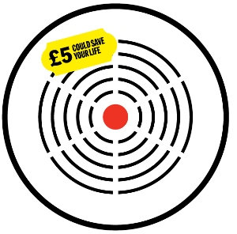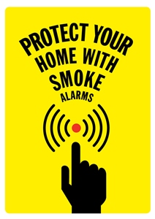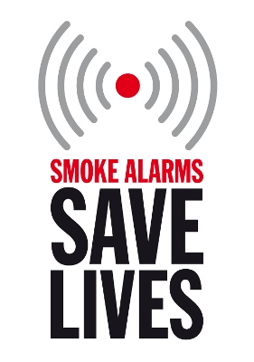

Return to top
Snow and ice in Cornwall
Snow and severe cold weather can cause disruption and can also affect more vulnerable people.
Practical steps
- To prevent freezing of internal pipes it is recommended that you turn off your water supply to prevent pipes from bursting. Locate the stop-cock inside your home, this is usually under the kitchen sink. Also, know the location of the stop-cock outside of your home, if you cannot find it, contact South West Water.
- Keep torches (and any batteries) to hand in case lighting fails or you need to switch off power.
- Keep important emergency numbers near your home - a 24-hour plumber, an emergency salvage and clean-up company, usually listed under 'Carpet and Upholstery Cleaners' in directories.
- Check your buildings and contents insurance details. Most will be pleased for you to arrange damage limitation with plumbers and cleaners yourself. Note any emergency contact telephone numbers.
- If your house has any exposed pipes, lag them with thick material, old blankets etc. If lofts are very cold, leave trap doors open.
- If you are away from your house overnight or for any long period, leave the heating system on a low setting to prevent pipes freezing. If practical, switch off water and drain pipes.
- Ensure everyone living in your home knows where the water stop cock and electricity mains switch, are located.
- If you have a battery radio check it and ensure you have spare batteries.
- If you use candles, electric blankets, or an open fire, be aware of the hazards and view safety information to prevent a fire in your home during the winter.
Link - http://bit.ly/2jteMjY

Return to top
Thatch cottages
When a fire takes hold of a thatched property the damage is devastating. Chimneys can be a main cause of fire in thatched properties so ensuring your chimney is swept and kept in good working order is essential.
Follow our advice to keep your property as safe as possible. Remember if you have a fire, get out, stay out and call 999.
Link - http://bit.ly/1axuDCS
Image - R:\TEMPLATE\Critical Control - News Desk\Images\Incidents
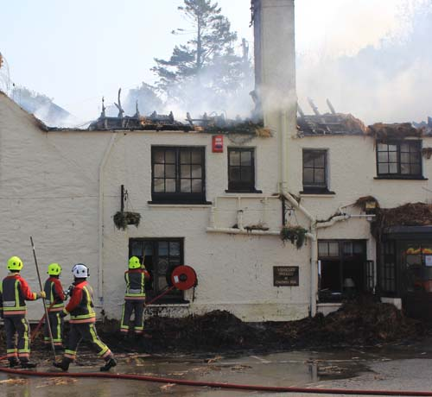

Return to top
Tumble Dryers – also within ‘Washing machines’
Tumble dryers and washing machines contain powerful motors with fast moving parts that get very hot. If you do not clean and maintain your machine, excess fluff or lint can build up over time and catch fire.
Remember to:
- Always read and follow the manufacturer’s instructions before using your dryer
- Never leave your appliance unattended or running overnight
- Never overload your washing machine or dryer or put items in that have been used to soak up flammable liquids
- Keep your dryer well ventilated ensuring the vent pipe is kink free, not blocked or crushed in any way
- Clean the filter in your dryer after every use
- Have your dryer serviced regularly by a qualified engineer
- Don't ignore the warning signs
- Does your tumble dryer smell of burning?
- Are your clothes taking longer to dry?
- Do the clothes feel hotter at the end of the cycle?
- Does the external vent flap stay shut when the dryer is on?
- If you notice any of the above, clean the filter and check the vent pipe immediately.
For more information visit our website which also has information on product recalls:
Link - http://bit.ly/2460ZNj
Image - R:\TEMPLATE\Critical Control - News Desk\Images\Incidents
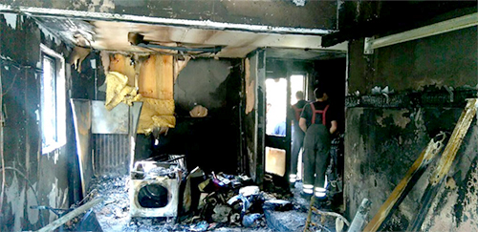Return to top
Washing machines – also within ‘Tumble Dryers’
Tumble dryers and washing machines contain powerful motors with fast moving parts that get very hot. If you do not clean and maintain your machine, excess fluff or lint can build up over time and catch fire.
Remember to:
- Always read and follow the manufacturer’s instructions before using your dryer
- Never leave your appliance unattended or running overnight
- Never overload your washing machine or dryer or put items in that have been used to soak up flammable liquids
- Keep your dryer well ventilated ensuring the vent pipe is kink free, not blocked or crushed in any way
- Clean the filter in your dryer after every use
- Have your dryer serviced regularly by a qualified engineer
- Don't ignore the warning signs
- Does your tumble dryer smell of burning?
- Are your clothes taking longer to dry?
- Do the clothes feel hotter at the end of the cycle?
- Does the external vent flap stay shut when the dryer is on?
- If you notice any of the above, clean the filter and check the vent pipe immediately.
For more information visit:
Link - http://bit.ly/2460ZNj
Image - R:\TEMPLATE\Critical Control - News Desk\Images\Incidents
Return to top
Wildfires
Every year, Cornwall Fire, Rescue and Community Safety (CFRCS) Service attend many gorse/vegetation fires that are also known as wild fires. We invite responsible parties, who may be considering controlled burning to:
1. Put in place an effective burn plan.
2. Inform Critical Control Centre of intended burns, by calling 0203 162 2240.
3. Draw upon CFRCS Service knowledge.
4. Make use of limited fire and rescue service resources i.e. beaters, Landrover crew to observe specific burns.
For more information about wild fires, the rules and applying for a licence, visit our website:
Link - http:/ /bit.ly/1XZ0MO1
Image - R:\TEMPLATE\Critical Control - News Desk\Images\Incidents
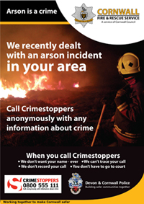
Monthly safety campaigns
The below images can be used when there are no incidents to report and can be found from:
Image - R:\TEMPLATE\Critical Control - News Desk\Images\Campaigns
January
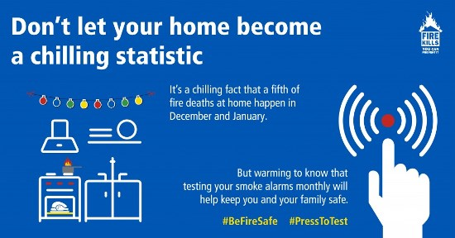
February
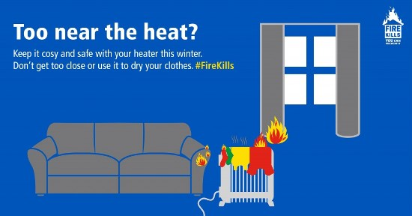
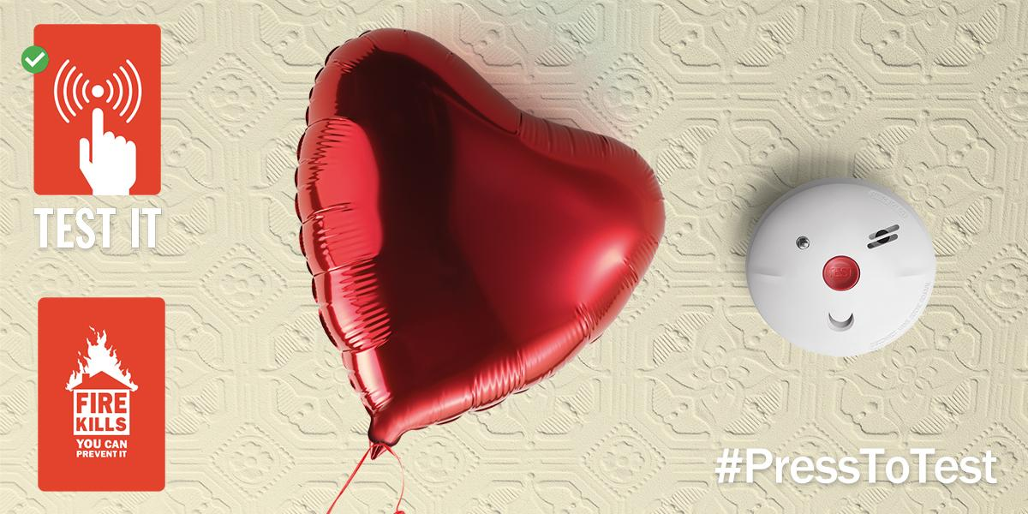

March

April
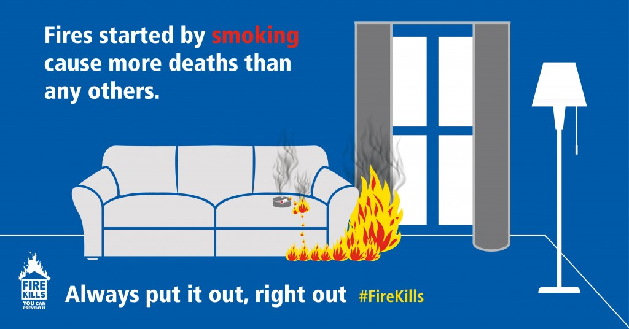
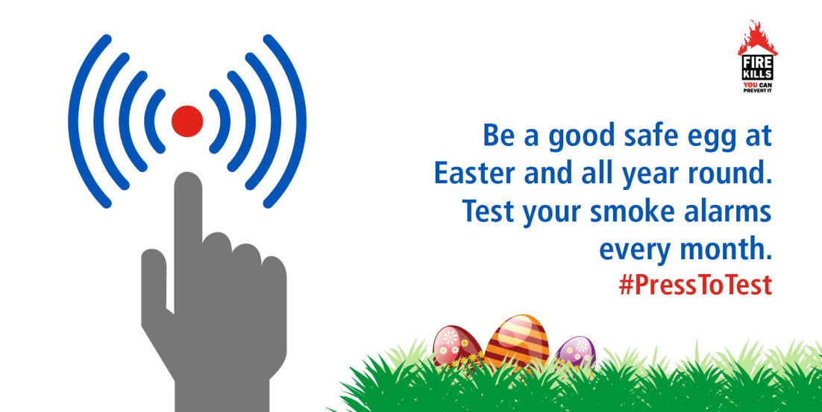

Return to top
May
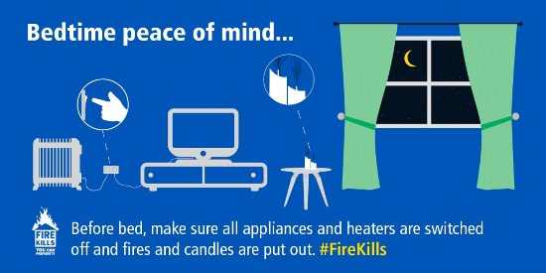

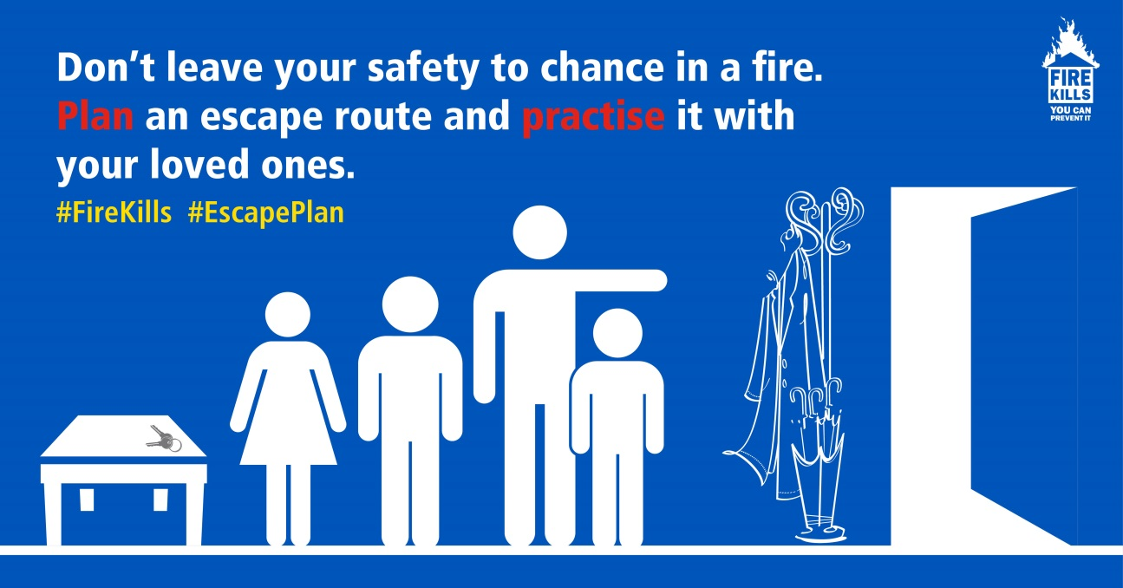

Return to top
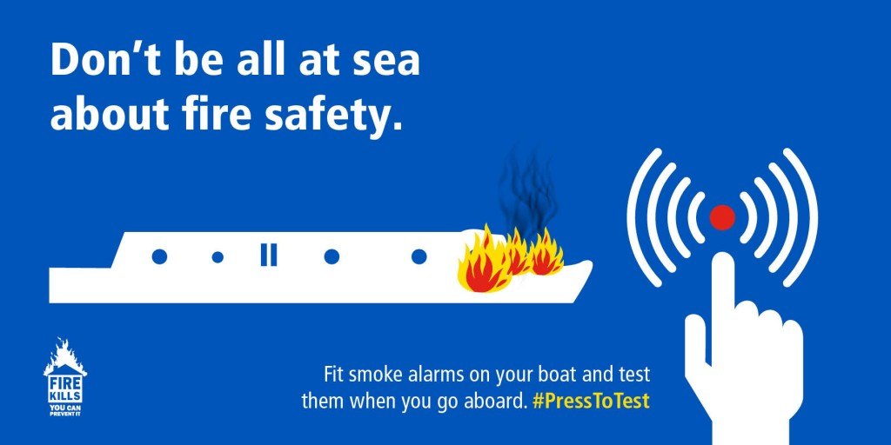
June

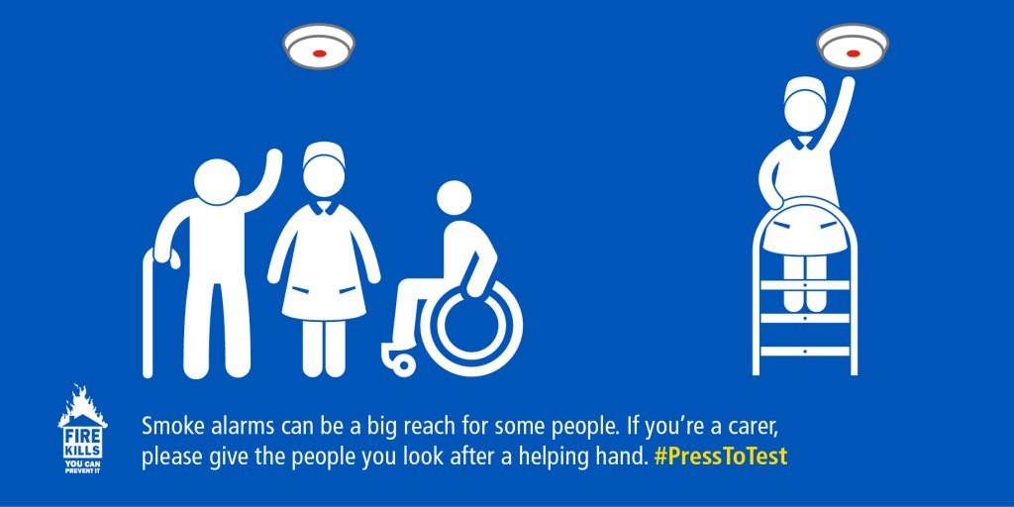

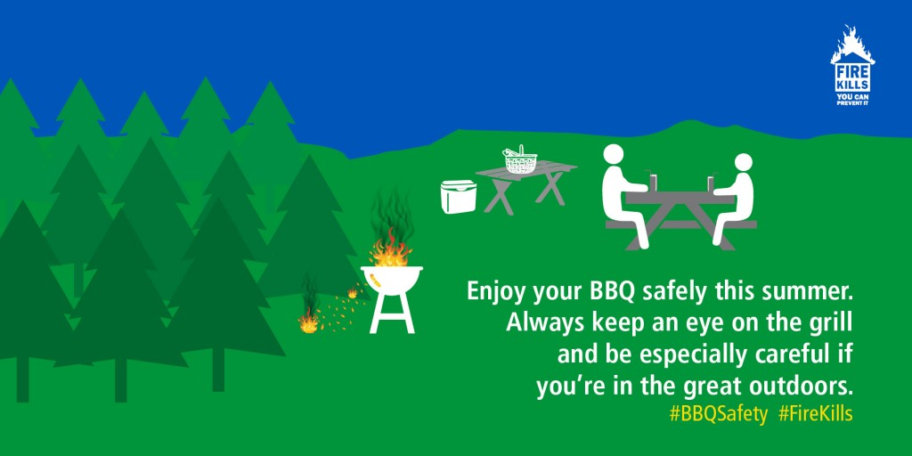

Return to top
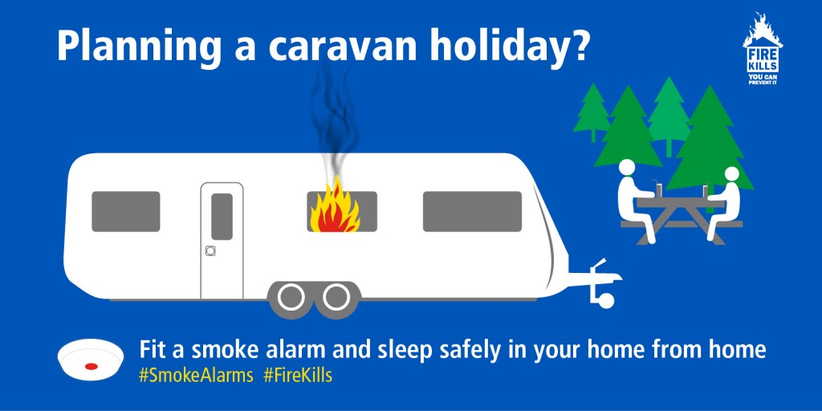
July

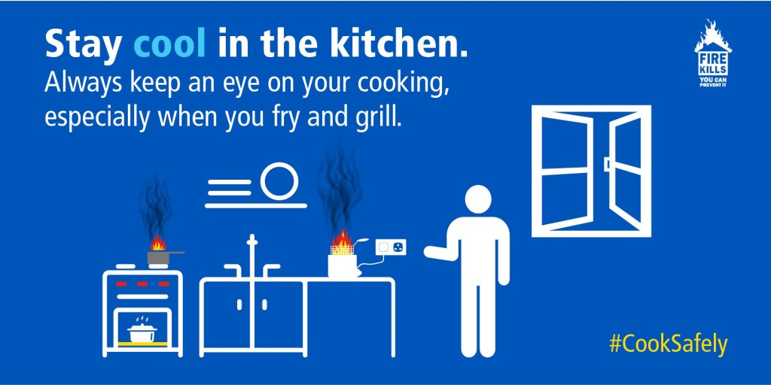

August
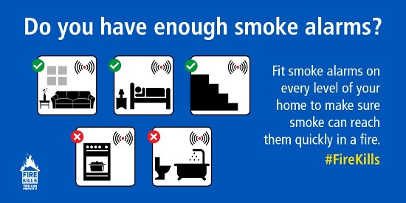
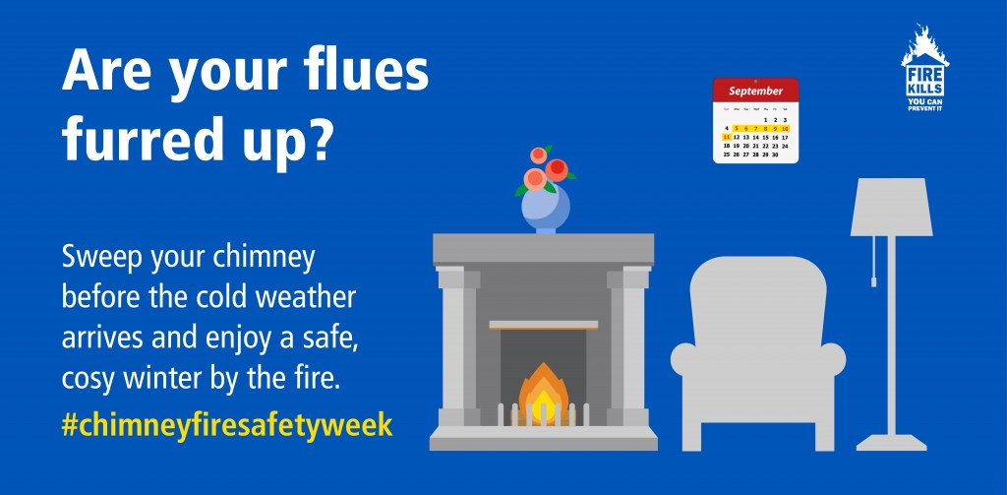
September

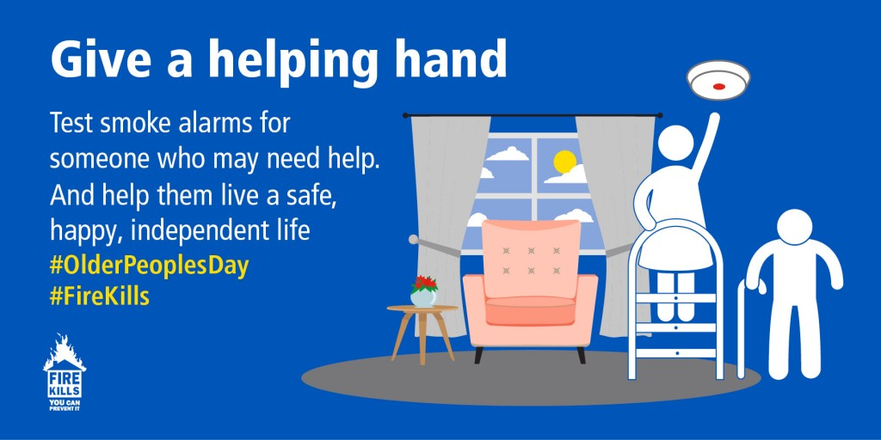
October

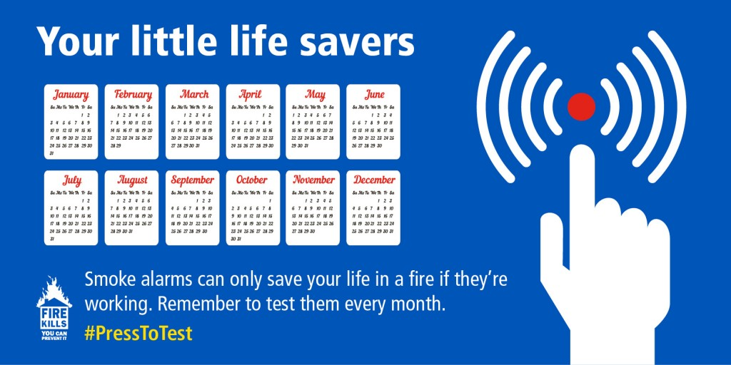

Return to top
November
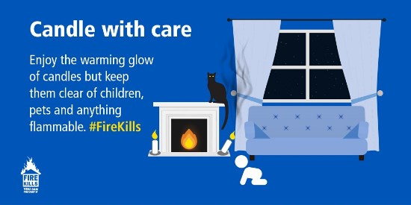

Return to top

December
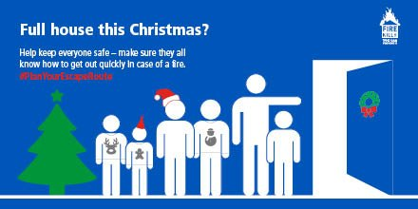
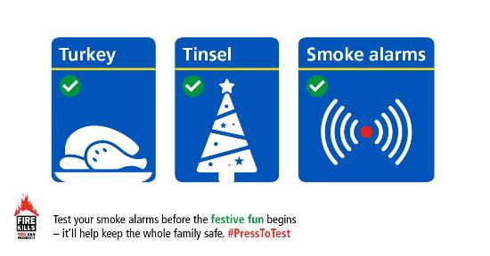

Return to top

